ALGORITHM DESIGNS
Flow Charts

Log In

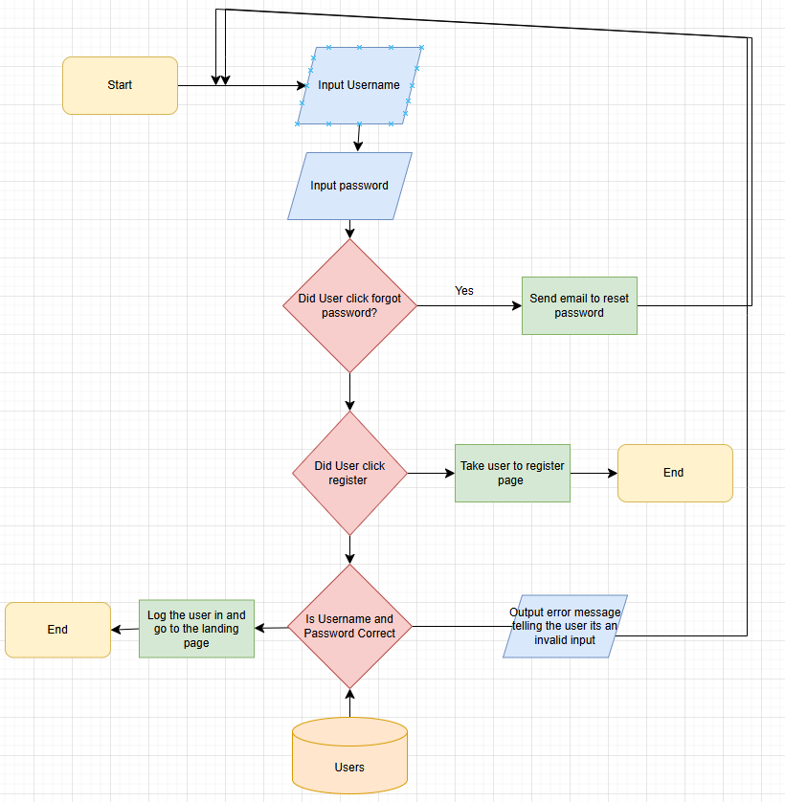

The user will be prompted to input their username and passwords then the system will check if the user has made actions like clicking forgotten password, if this is the case the system will send a password reset email to the user. If the user clicks the register button the system will redirect them to the register page. If the user doesn’t click any of those the system will check if the password and username is valid, if its not the system will output an error message that the user log in info is in invalid thus sending them back to re-enter their log in info. If the user information is correct the system will log the user in and redirect them to the home page.
Register
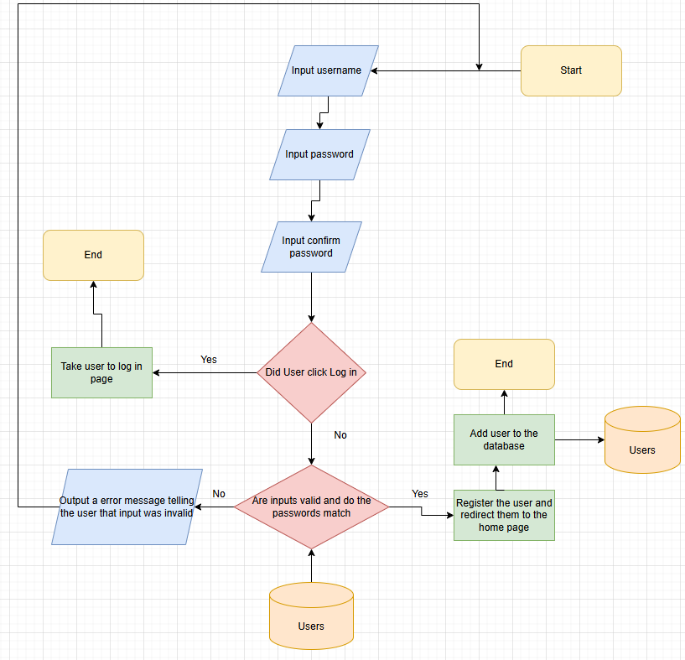
The user will be prompted to input their username and password and also to confirm the password. If the User interacts with the log in button, the system will redirect the user to log in page. If not then the system will check if the user inputs were valid. If the inputs were not valid the system outputs an error message informing the user that the input is invalid and prompts them to re-enter their log in details. If the inputs were valid then the system registers the user and adds them to the database.

Booking a Room
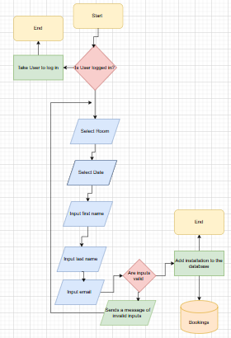
If the user isn’t logged in to the system they will be redirected to the log in page. The User is the prompted to select a Room they wish to book as well as the date they’re booking for. The user is the prompted to input data needed and the system will check if its valid or not. If its valid the system will register the booking into the database.

Editing Room Availability
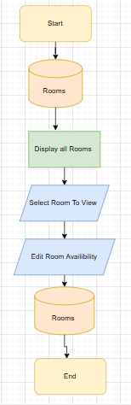
The system displays all the rooms to the user and prompts the user to select a room. The user is then given the option to edit the room availability. The choice is then stored in the database.

Staff Confirmation of Order

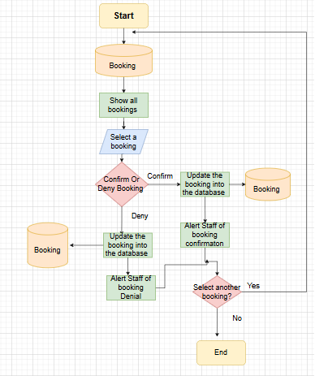
The system enters the booking database and shows all the bookings to the user which the user can then select a booking and either confirm or deny the booking. Depending on the choice the system will alert the staff that booking has been confirmed or denied then it updates into the booking database. It then prompts the user to select another booking or not.

DATABASE DESIGN
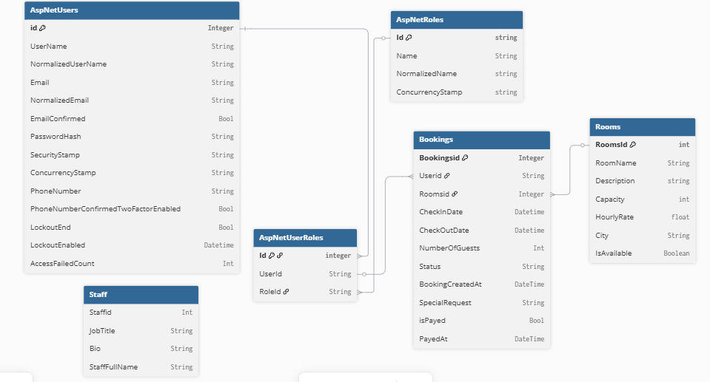

DATA DICTIONARY
ASPNETUSERS
Column | DataType | Required | Default | Validation | Key Type
id | String | Yes |  |  | Primary
UserName | string | yes |  |  | None
NormalisedUserName | String | Yes |  |  | None
Email | string | Yes |  | Must include a valid email structure, must have “@” symbol, must have a domain name. | None
Normalised Email | String | Yes |  |  | None
EmailConfirmed | Bool | Yes |  | Users must confirm their email | None
PasswordHash | String | Yes |  |  | None
SecurityStamp | String |  |  |  | None
ConcurrencyStamp | String |  |  |  | None
PhoneNumber | String |  |  |  | None
PhoneNumberConfirmedTwoFactorEnabled | Bool |  |  |  | None
LockoutEnd | Bool |  |  |  | None
LockOutEnabled | Datetime |  |  |  | None
AccessFailedCount | Int |  |  |  | None

ASPNETROLES
Column | Data type | Required | Default | Validation | Key Type
Id | string | Yes |  |  | Primary
Name | String | Yes | Users Id |  | None
NormalizedName | String | Yes |  |  | None
ConcurrencyStamp | String | Yes

ASPNETUSERSROLES
Column | Data type | Required | Default | Validation | Key Type
Id | int | Yes |  |  | Primary
UserId | String | Yes | Users Id |  | Foreign
RoleId | String | Yes |  |  | None

BOOKINGS
Column | Data type | Required | Default | Validation | Key Type
BookingsId | int | Yes |  |  | Primary
UserId | String | Yes | UserId |  | Foreign
RoomsId | Int | Yes | RoomsId |  | Foreign
CheckInDate | DateTime | Yes |  | Must be today or a future date | None
BookingCreatedAt | DateTime | Yes |  |  | None
SpecialRequest | String | No | None |  | None
IsPayed | Int | Yes | False |  | None
PayedAt | DateTime | Yes

ROOMS
Column | Data type | Required | Default | Validation | Key Type
RoomsId | Int | Yes |  |  | Primary
RoomsName | String | Yes |  |  | None
Description | String | No | None |  | None
Capacity | Int | Yes |  | Must be a number, Must be greater than 0 | None
HourlyRate | Float | Yes |  | Must be a number. Must be rounded to 2 decimal points | None
City | String | Yes |  | Must contain letters only. Must be a real city in the world | None
IsAvailable | Boolean | Yes |  |  | None

STAFF
Column | Data type | Required | Default | Validation | Key Type
StaffId | Int | Yes |  |  | Primary
JobTitle | String | Yes |  |  | None
Bio | String | Yes |  |  | None
StaffFullName | String | Yes |  |  | None

SITEMAP
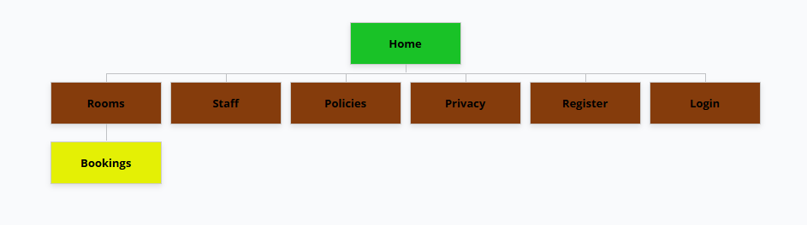

WIREFRAME
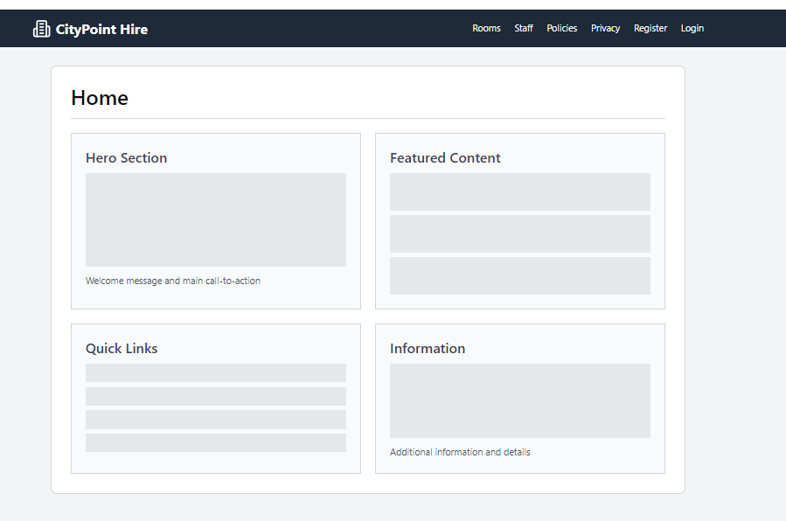
View rooms available
Section for viewing staff information
Link for viewing policies
A link for user registeration
Link for user to log in to system
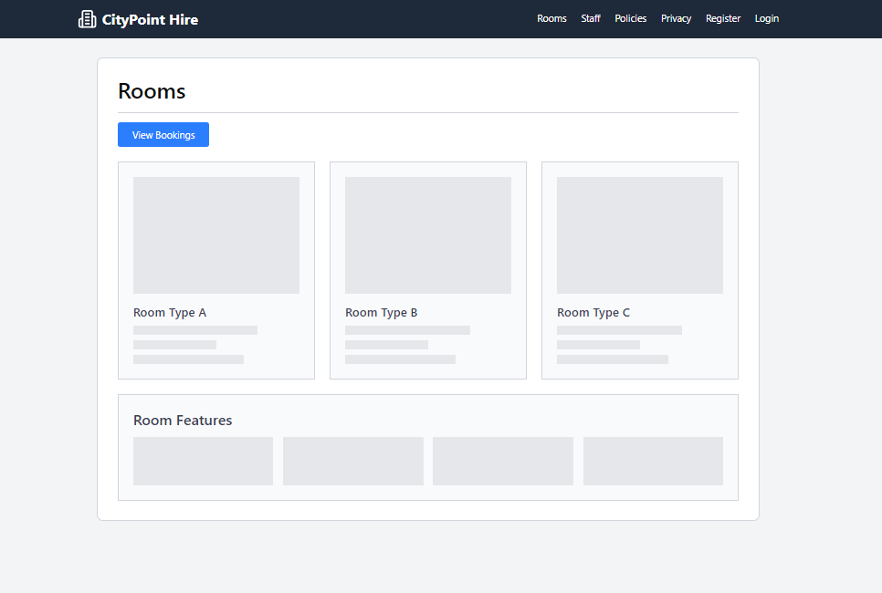
Placeholders for the different rooms
Details about the different rooms
Button to view room bookings
Brand for the company

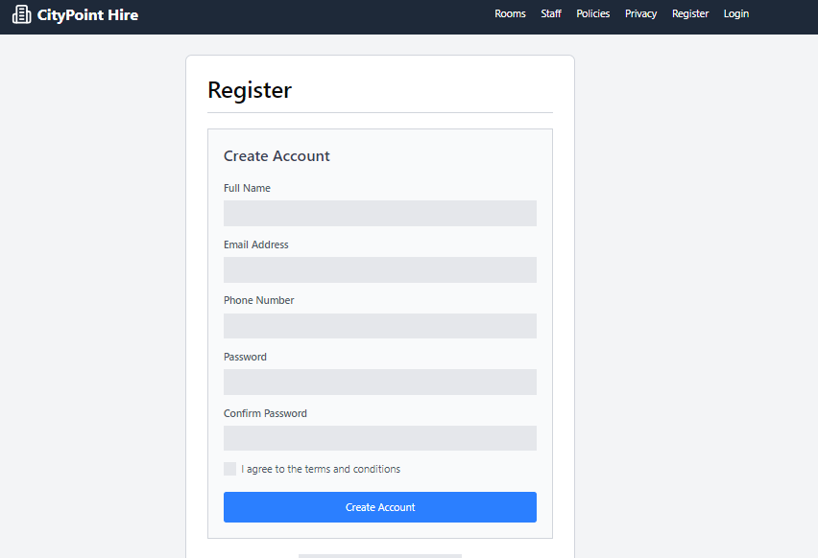
Field to create account
Field to input password
Field to input phone number
Fields to enter Full name
Field to enter username and email address
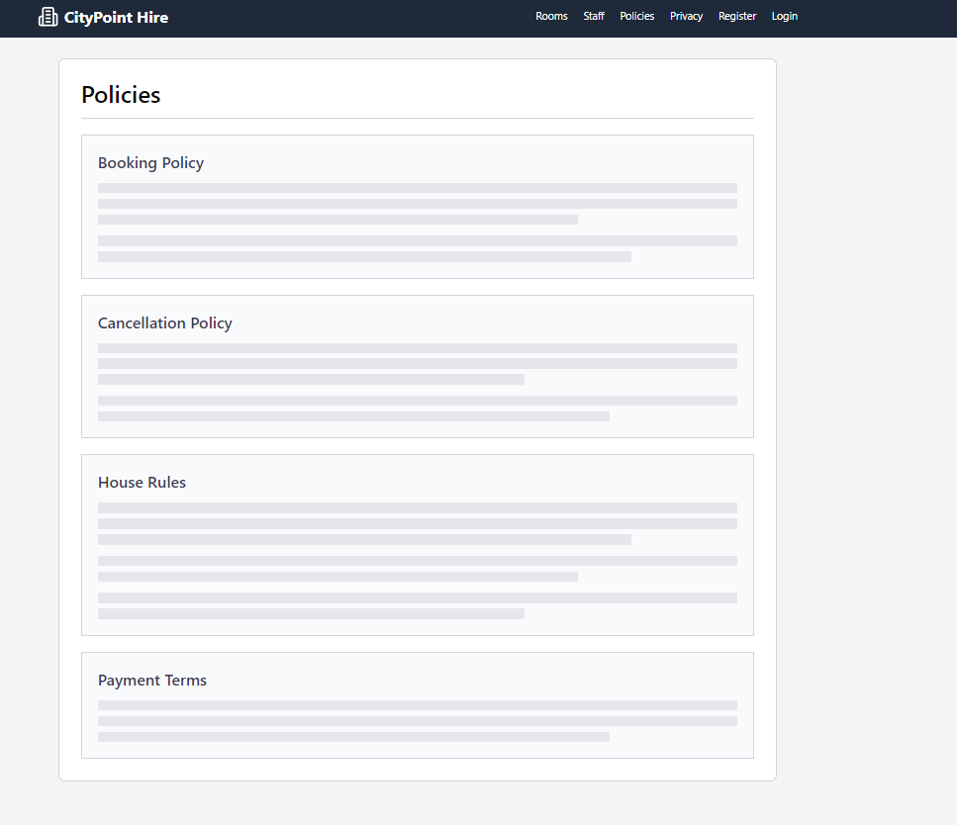
This describes how payments are being handled, including the payment schedule, accepted payment methods, and the timing of charges.
These are the list of expectations for behavior and activities within the property. This ensures guests respect the space and maintain a harmonious environment.
Outlines the rules and conditions under which a booking can be canceled and any associated fees or timeframes for cancellations.
This describes the guidelines for making and managing bookings.
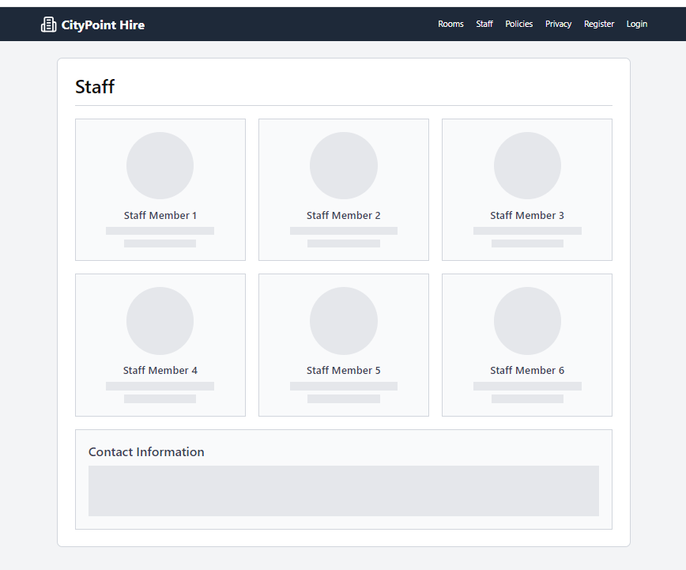
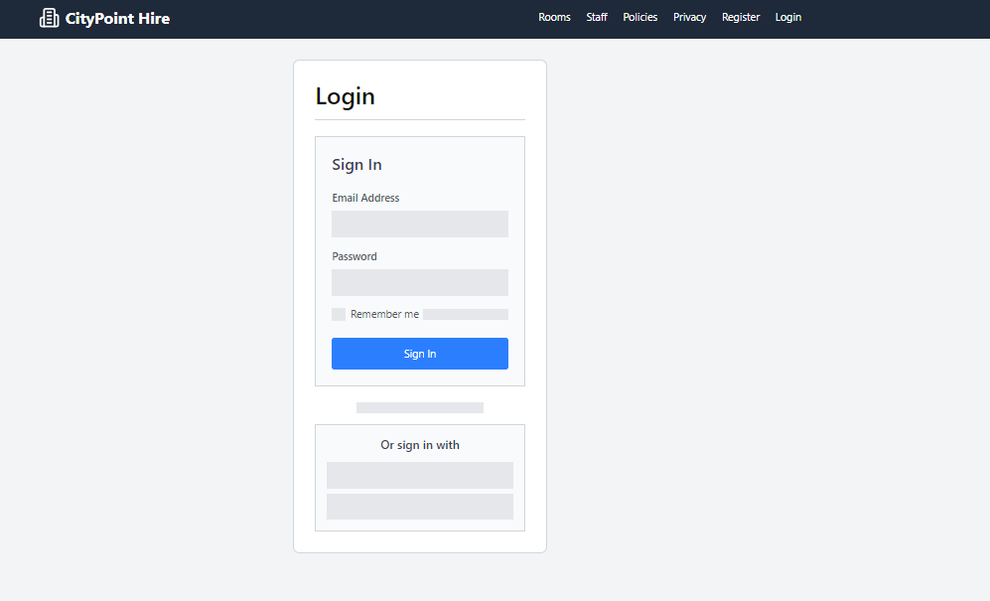
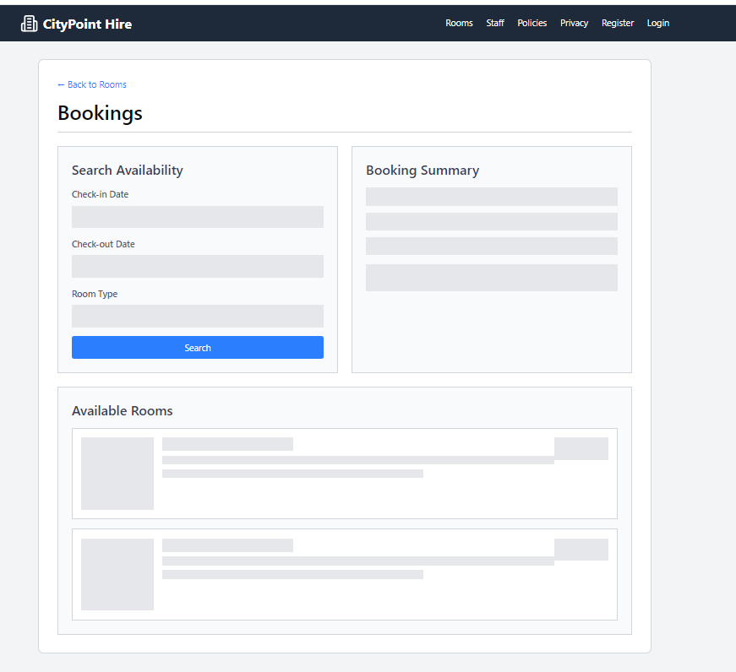
this is a space that will display a brief overview of the user’s booking choices after selecting a room
This area will dynamically update to show available rooms based on the search criteria entered in the form above.
This section allows users to check the availability of rooms.

TEST STRATEGY
Date of test | Component to be tested | Type of test to be carried out | Prerequisites and dependencies
30/1/2026 | Log in | Whitebox testing, Black box testing, Functionality, Security Integration | The log in page must be created and the migration and update-database must have been completed. The controller logic must have been added to handle user errors.  Test Data:  Normal  Email: manual@gamil.com  Password: Password123!  Erroneous  Email: noemail  Password: 678  Extreme  Email: manual@gamil.com  Password: musta3#  (Exactly 6 characters which is the minimum)
30/1/2026 | Register | Whitebox testing, Black box testing, Functionality, Security Integration | Register page must be fully functional. The migration and update-database must have been completed. The controller logic must have been added to handle user errors.  Test Data:  Normal  Email: manual@gamil.com  Password: Password123!  Erroneous  Email: noemail  Password: 678  Confirm Password: 678  Extreme  Email: manual@gamil.com  Password: musta3#  Confirm Password: musta3#
30/1/2026 | Log Out Function | Black box testing, Functionality testing, Security Integration | No test data needed. The Log in system should be fully functional and allow users to create accounts and save their data to a database and the log out button must be visible to the user.
30/1/2026 | Link buttons on the navigation bar and the footer | Black box Functionality Integration | All the pages for each link must be completed and each link must be functional.  The Navigation bar must be made and fully functional.  Tester must check each link to see if its functional and leads to the correct page
30/1/2026 | Accessibility features | Black box Functionality Integration | Accessibility features must be fully functional and accessible to the user.  Tester should check each accessibility feature to test if its functional. No test Data needed.
30/1/2026 | Cookies Functionality | Black box Functionality integration | Cookies must be made. Tester should check if the cookies show up when new users enter the website. No test data required
30/1/2026 | Home Page | White box, Black box, Functionality Integration | Home Page must be fully functional.  Tester must be able to access otherpages from the home page  No test data needed.
30/1/2026 | Booking a room | Blackbox Testing, White box Testing, Functionality Testing, Security Testing, Session Management testing | Test Data would be required.  The Models and Controllers must be created and there must be a logged in user to test it. The tester should book a room and fill out all the fields and make sure it successfully logs Room and displays it. They must be able to edit, delete and view the details of the booking.  Test Data:  Normal  Room: Meeting Room,  Phone number: 07895765932  Email: Manual@gmail.com  Date: 24/2/2026  Erroneous  Room- Chain(Not a room that exists in the system)  Phone Number: number( Must be a valid phone number format)  Email: email(Must contain an @ symbol and must contain a domain eg .com)  Extreme  Phone number: 07895765932( Maximum amount of numbers for a Uk phone number)
30/1/2026 | Edit button in bookings page | Blackbox Testing, Functionality integration | No test data required.  The Bookings Page must have already been created, and the booking room fuctionality must have also been created. The account registration must have been created and there must be a logged in user to test it. The Tester should click details to ensure it loads up the correct page.
30/1/2026 | Delete button on the bookings page | Blackbox testing, Functionality testing, integration testing | No test data required.  The Bookings Page must have already been created, and the booking room fuctionality must have also been created. The account registration must have been created and there must be a logged in user to test it. The Tester should click details to ensure the user to delete the booking.
30/1/2026 | Details button on the bookings Page | Blackbox testing, Functionality testing, integration testing | No test data required.  The Bookings Page must have already been created, and the booking room functionality must have also been created. The account registration must have been created and there must be a logged in user to test it. The Tester should click details to ensure the page loads up with all the correct booking details
30/1/2026 | Filter by Availablity | Whitebox testing, black box testing , Functionality Integration, Integration Testing | No test data required. The bookings page must have already been created. The account registration must have been created and there must be a logged in user to test. The tester must click the filter by availability button and select date and the system must show all available rooms to be booked on the specific date
30/1/2026 | Staff Confirmation of Booking | Blackbox testing, Functionality testing, integration testing | No Test data required. Staff account must be created as well as the Customer account. The tester must create a booking using the customer account then switch to the Staff account to check if they can confirm or deny the booking.

